***NAME : Himanshu Dixit***

***ENROLL NO. : B64178***

***BATCH : B10***

***SOFTWARE DEVELOPMENT FUNDAMENTAL LAB-I(15B17CI171) Assignment Sheet (WEEK-9 PHASE-2)***

***Lab B***

***Q1.*** *Write a C program to create a structure to store name, number and rank. Access the structure members with Pointer.*

**Solution:**

#include <stdio.h>

struct my_structure {

char name[20];

int number;

int rank;

};

int main()

{

struct my_structure variable = {"StudyTonight", 35, 1};

struct my_structure *ptr;

ptr = &variable;

printf("NAME: %s\n", ptr->name);

printf("NUMBER: %d\n", ptr->number);

printf("RANK: %d", ptr->rank);

return 0;

}

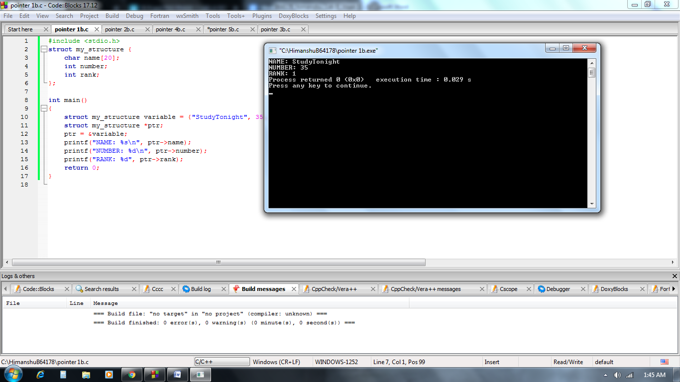

***Q2.*** *Write a function in C to compare two numbers and return a pointer to the large number.*

**Solution:**

#include <stdio.h>

int * larger(int *x, int *y)

{

if(*x > *y)

return x;

else

return y;

}

void main()

{

int a = 15;

int b = 92;

int *p;

p = larger(&a, &b);

printf("%d is larger",*p);

}

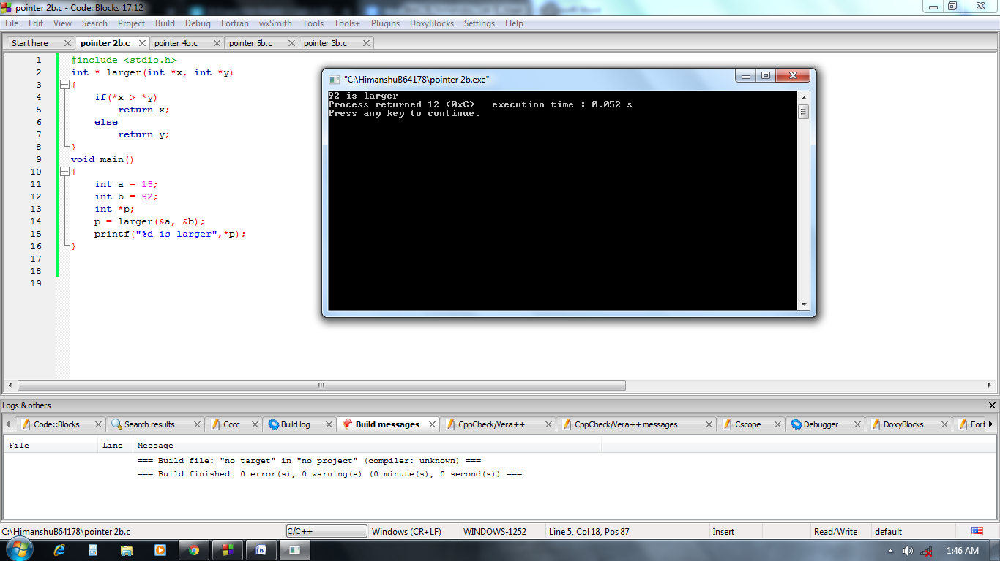

***Q3.*** *Write a C program to sort an array using pointers.*

**Solution:**

#include <stdio.h>

void sort(int n, int* ptr)

{

int i, j, t;

for (i = 0; i < n; i++) {

for (j = i + 1; j < n; j++) {

if (*(ptr + j) < *(ptr + i)) {

t = *(ptr + i);

*(ptr + i) = *(ptr + j);

*(ptr + j) = t;

}

}

}

for (i = 0; i < n; i++)

printf("%d ", *(ptr + i));

}

int main()

{

int n = 5;

int arr[] = { 0, 23, 14, 12, 9 };

sort(n, arr);

return 0;

}

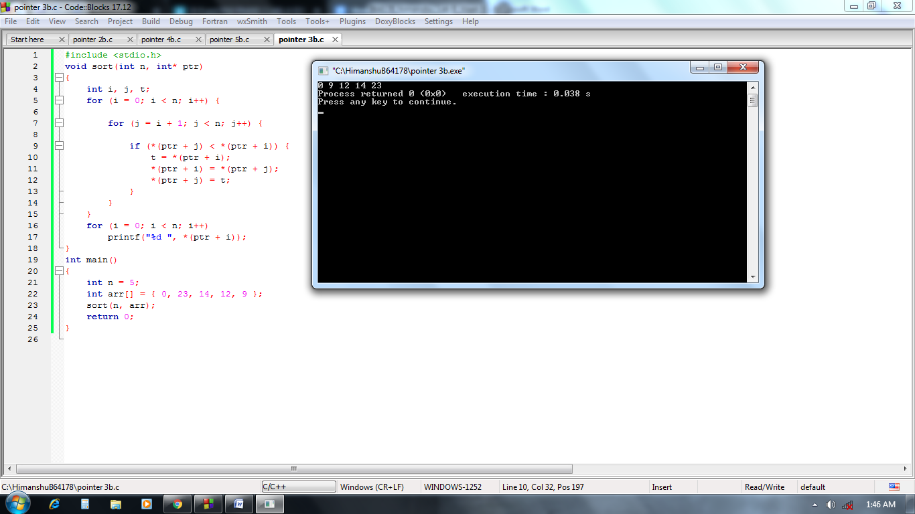

***Q4.*** *Write C program to make array of pointers to the character to store a list of strings.*

**Solution:**

#include <stdio.h>

const int size = 4;

void main()

{

char* names[] = {

"amit",

"parmar",

"sandeep",

"nikhil"

};

/*char *n,names[][50]= {

"amit",

"parmar",

"sandeep",

"nikhil"

};

n=&names[0][0];*/

for (int i = 0; i < size; i++) {

printf("%s\n", names[i]);

}

}

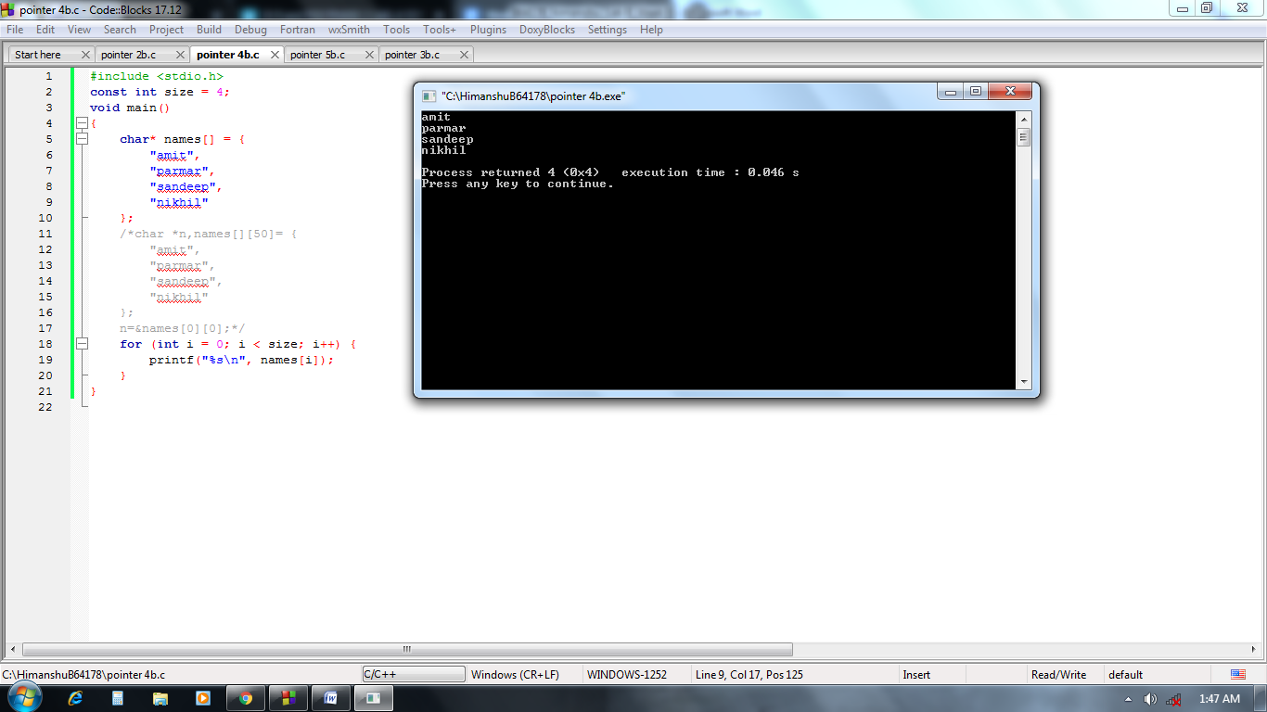

**Q5.** Write a C Program to swap numbers in Cyclic Order using Call by Reference.

***Example Output***:

Enter a, b and c respectively: 1

2

3

Value before swapping:

a = 1

b = 2

c = 3

Value after swapping:

a = 3

b = 1

c = 2  
**Solution**:

#include <stdio.h>

void cyclicSwap(int *a, int *b, int *c);

int main() {

int a, b, c;

printf("Enter a, b and c respectively: ");

scanf("%d %d %d", &a, &b, &c);

printf("Value before swapping:\n");

printf("a = %d \nb = %d \nc = %d\n", a, b, c);

cyclicSwap(&a, &b, &c);

printf("Value after swapping:\n");

printf("a = %d \nb = %d \nc = %d", a, b, c);

return 0;

}

void cyclicSwap(int *n1, int *n2, int *n3) {

int temp;

// swapping in cyclic order

temp = *n2;

*n2 = *n1;

*n1 = *n3;

*n3 = temp;

}

